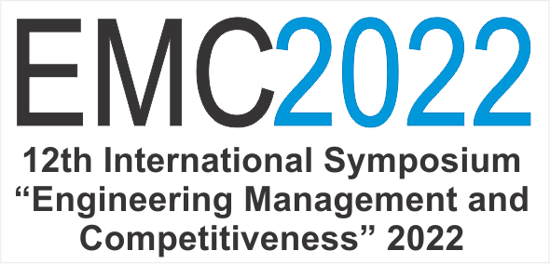

REGISTRATION FORM

Dear colleagues,
Thank You for Your interest in the 12th International Symposium Engineering Management and Competitiveness 2022 (EMC 2022).

Please, fill in the Registration form and send it to the following e-mail address of the Symposium: emc@tfzr.rs

You will be informed on your paper reception at most three days after the reception.

Organizing committee of EMC 2022

Title, abstract, key words and section
Title of the paper in English:
Abstract in English (up to 200 words):
Key words in English (up to 5 key words):
Author’s suggestion concerning thematic field:

Authors’ names and name of affiliation / organization they are employed in
Name, surname, affiliation of the first author:
Organization:
Name, surname, affiliation of the second author:
Organization:
Name, surname, affiliation of the third author:
Organization:
Name, surname, affiliation of the fourth author:
Organization:
Name, surname, affiliation of the fifth author:
Organization:

Other information about the first author
Name, surname, affiliation:
Address and place of living:
Personal identification number (PIN / JMBG):
Contact phone number and e-mail:

Other information about the organization in which the first author is employed
Name, address, city, country:
Registration number:
Code:
Bank account number and the name of the bank:
Name, surname of the authorized person:
Evidence number of VAT taxpayer:
Phone number, fax, e-mail:
Contact person in accounting office, phone number:

In addition, select one of the available options for payment of registration fee and method of presentation.

The invoice for registration fee payment should be addressed on:

1. The first author

2. The organization in which the first author is employed

Registration fee:
Registration fee: 10.000 RSD per paper; 100 € per paper for foreign participants.

Registration fee includes:
- Attending all symposium sections.
- Proceedings, Program of the Symposium, and promotional materials.
- Lunch for all participants: June 17th 2022.
- Snacks and refreshments during breaks.

Further information regarding fees:
- Registration fee does not include accommodation and travel costs.
- Registration fee includes VAT.
- Payments can be performed on Faculty’s account upon the invoice issued after submitting the paper.

Please note that in case of necessity (due to the COVID-19 pandemic) the symposium will be held online.

Types of paper presentations:

1. Oral presentation

2. Poster presentation

If you choose "Poster presentation", we will assume that you are unable to attend the symposium and, consequently, you will not have to present your paper. In this case, however, please send the presentation of it (up to 3 slides, which in. ppt or. pdf format should be sent to the Organizer) for the poster session, technically prepared according to the guidelines which will be included along with the review of your paper.

